Welcome!
Date
Name
Spouse
Address
City
State Zip _________
Email

Please Contact By
❑ Card  Phone  Visit

Telephone Best Time to Call
Home ______________
Work ______________

Guest: First Time Second Time
Are you a church member: yes no
Church
City, State

Circle Appropriate Age/Grade Group(s)
Preschool: Ages: B-1 2-3 4-5
Children: Grades: K 1 2 3 4 5 6
Youth: Grades: 7 8 9 10 11 12
Adults: Ages:18-29 30s 40s 50s 60s+

How did you learn about our church?
Newspaper Friend Yellow Pages Mail
Other

I am a guest of:

New in the Community? Yes No
Names & ages of children at home

Weekly Service & Activity Schedule

Nov 27, 2016
9:45 a.m. Sunday School
11:00 a.m. Worship Service
6:00 p.m. Evening Service

Week of Nov 27, 2016

Wednesday 6:30 pm………………..…Meal/Bible Study
December
4…..New Commandment Kids go to Elgin Nursing Home
4……………………………Spiritlifters SS Christmas Party
6……………………………………..……..Ladies Craft Night
4-11……..………Week of Prayer for Lottie Moon Missions
8……………………….………..…………….Adult Fellowship
11………………………………..Church Christmas Program
16…………………….…………..Adult I SS Wrapping Party
18………………….…………..…………….Business Meeting
31………………………………New Year’s Eve Watch Party

Join us for a Ladies Craft Night!!
Tuesday, Dec. 6 @ 6:30
We will be making Christmas cards for wounded warriors. The cost is $5/person to cover supplies and postage. Contact Brenda Williams if you want to attend so she can have the appropriate amount of supplies.
Church Christmas Program

Sunday Dec 11

Not just for the kids this year! If you would like to participate in the program, there is a sign up sheet in the sanctuary. All are welcome to participate…individuals, groups, Sunday School classes…

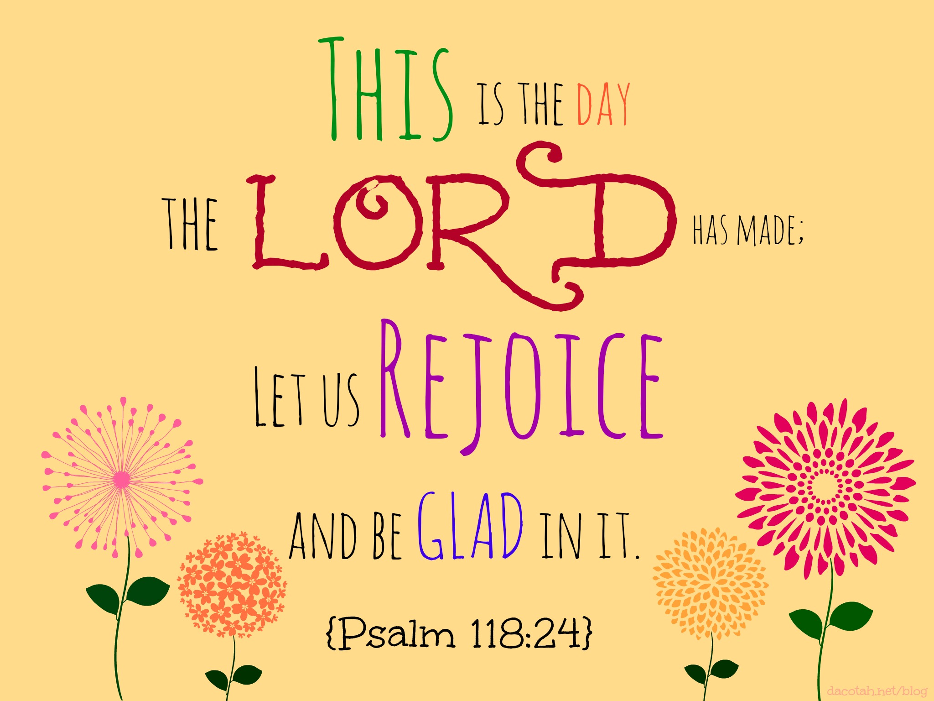

Knobbs Springs Baptist Church

November 27, 2016

Church Information:

KnobbsSpringsBC.com KnobbsSpringsBaptist@gmail.com

1662 CR 305, McDade, Texas 78650 512-273-2743

David Atwood, Pastor Cell 512-470-5098

Patti Radford, Office Manager Cell 512-968-7821

